http://www2.wheaton.edu/bgc/archives/treasure/tr99/rescuetalka.htm

"Lord, When Did We See You A Stranger": Scenes of City Rescue Work from the BGC Archives

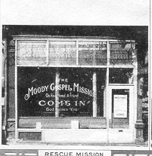

[This talk was given by Robert Shuster of the BGC Archives on May 8, 1999 at 9:30am in Barrows Auditorium in the Billy Graham Center. The talk was part of the annual Treasures of Wheaton program, given on Alumni Day. The other speakers were Rev. Lawrence Thompson of the College's Archives, David Malone of the College's Special Collections and Christopher Mitchell of the Wade Center.
Shuster's talk was illustrated by slides, most of which are imbedded in the text that follows. It also included audio tapes of excerpts from documents. Audio excerpts are indicated in the text that follows by italics.]

Pacific Garden Mission of Chicago, started in 1877. Rescue missions provided food and shelter for those considered the refuse of society - drunks, drug addicts, those who had stopped even pretending to cope with life. Fanny Crosby celebrated the rescue mission movement in her 1895 hymn, "The Rescue Band". Along with the food and other gifts, the mission workers[193c] also preached Christ and encouraged the men and women who drifted in to accept the salvation and hope that He offered. Gradually these rescue missions, also called city missions, began ministry to others in the slums. They would hold services, Bible studies, [47e] Sunday schools and prayer meetings for the poor families in the area, what we would now call daycare centers for working parents, [224d] becoming in effect a storefront church for their community as well as suppliers of physical needs, like [193e] clothing and jobs. Let me tell you some tales of the people who worked in these missions.

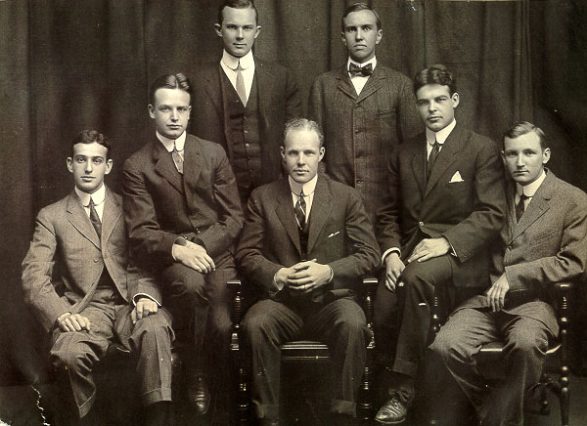

William Whiting Borden was born in 1887 to one of the wealthiest families in Chicago, owners of the Borden dairies. From an early age he dedicated himself to Christian service and at the age of 19 he was a sophomore at Yale University , preparing himself to be a foreign missionary. He was already known around campus for his commitment to Christian service as well as for his wealth. Presumably that is why he was approached by John Magee of the YMCA about some needs close to home. New Haven, the home of Yale, was also a seaport with a dock that provided irregular, occasional work for vagrants. As a result there was a large population of tramps, as well as recently released prisoners of the county jail. Magee saw the need for a rescue mission in the area and he saw the need for the undergrads of Yale to learn about the suffering of many in their own society. Magee and Borden began regularly praying about the needs of the dock area and With help from the Water Street Mission of New York, they started the Yale Hope Mission .

Borden recruited many of his classmates to come to the mission to befriend and witness to those who came in . He started a continuing tradition of involvement of the undergrads in the life of mission, because from the beginning the mission was aimed as much as at the elite students as the down and out hobos. Here are the comments of a student about the mission a few years after Borden's time, "I might say that sophomore year I was a pure atheist. Because there was so much selfishness and conceit in me, I was unhappy most of the time. The meeting at the mission opened my eyes. After attending several meetings, I saw that Jesus Christ could work miracles in men's lives. I began to get interested in the men – trying to help them get a new start and a firm hold on Christ. This work at the Mission made me a Christian. You may remember that after these few meeting when I became convinced that what I needed more than anything else was Jesus Christ as my Savior, I consented to lead a meeting. I lead several later on. The work at the mission has been the biggest joy of my college career. I had firmly impressed on me this joy of humble service."

Borden himself was the main benefactor of the mission in the beginning, not only recruiting students but providing the funds for the purchase of the building that served as chapel, hotel, and kitchen to the down and out of New Haven. His involvement was not just of the checkbook, but also of the heart. Magee remembered later that Borden city at night–on the streets, in a cheap lodging-house or some restaurant to which he had taken a poor hungry fellow to feed him–seeking to lead men to Christ."

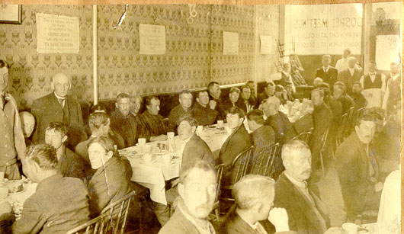

Jack Clark was one of the men of the mission who remembered Borden, "I came here on the 27th of march 1908. I was on a drunk and hadn't much use for religion....
That night Bill was there and he spoke to me. Bill was a great personal worker. He always believed in getting right down and talking to a man. If Bill had anything to say, he gave it right out....He would tell you to hope again; tell you of the God who'd made the universe and held you in the hollow of His hand and could help you if you'd only ask. That's the way he talked. He was one good boy. I could never forget him as long as I breathe-no, I never forget him. And he was barely twenty when I first knew him!... After my conversion I was baptized and joined the church. If Bill hadn't opened this mission, I'd been dead..... He was great at individual work. As a talker, he'd hasten through his address and get to work with the men, always aiming at getting close to the man he was talking to–always with his hand on his shoulder. He'd interest you quicker than the ordinary man because he had a more sympathetic way to start with.... I never knew a feller like him. He was a gentleman in every sense of the word and a Christian through and through. That was first and last in his life. He enjoyed life and people who came in contact with him, seeing his happy spirit, would say, ‘Why, life is worth living after all.'"

